**You can Unsubscribe from Chime right in your Chime account**

Here are the steps to unsubscribe from your Chime account:

* Log into your account
* Click on your picture in the upper right corner
* A drop down menu will appear - click on Billing Center

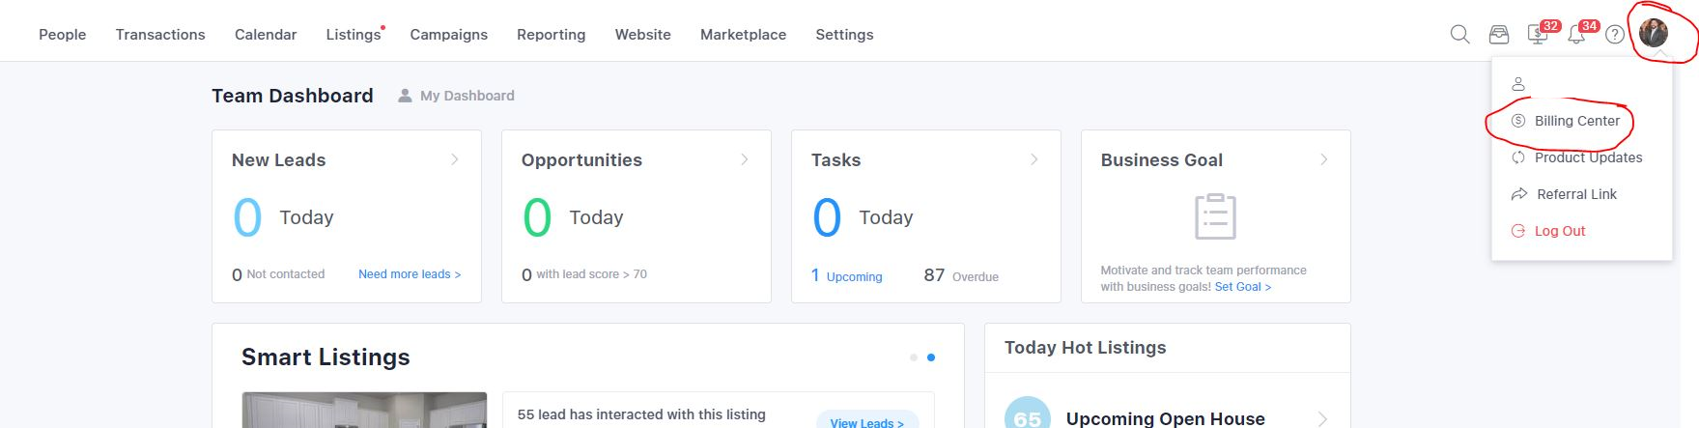

* A new page will open - click on Cancel Account

